Promotional Tools for AdaptDx

Welcome to the MacuLogix family! As your partner in practice, we have developed a set of tools to help you promote your clinic.

Contents:
- AdaptDx® logo
- MacuLogix logo
- Image of AdaptDx
- Image of AdaptDx with technician and patient
- AdaptDx description
- Videos:
  - AMD Warning Signs
  - What to Expect During the Test
  - RI: An Early Warning Sign of AMD
- AMD and dark adaptation information
- Social media postings
- Script to use while patients are on hold on the phone

For additional information or original images, email info@maculogix.com.

LOGOS AND IMAGES

AdaptDx logo
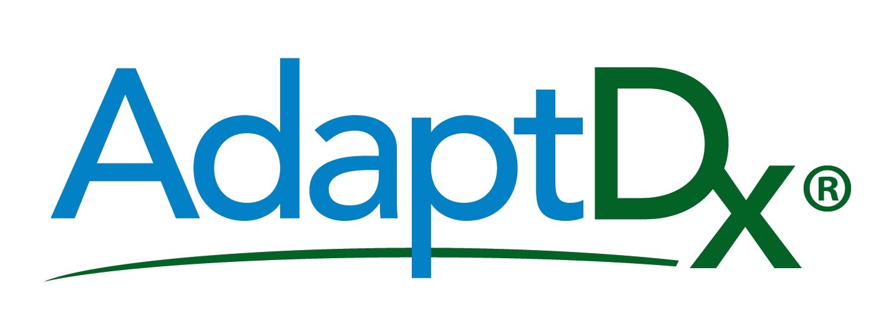

MacuLogix Logo

Image of AdaptDx product
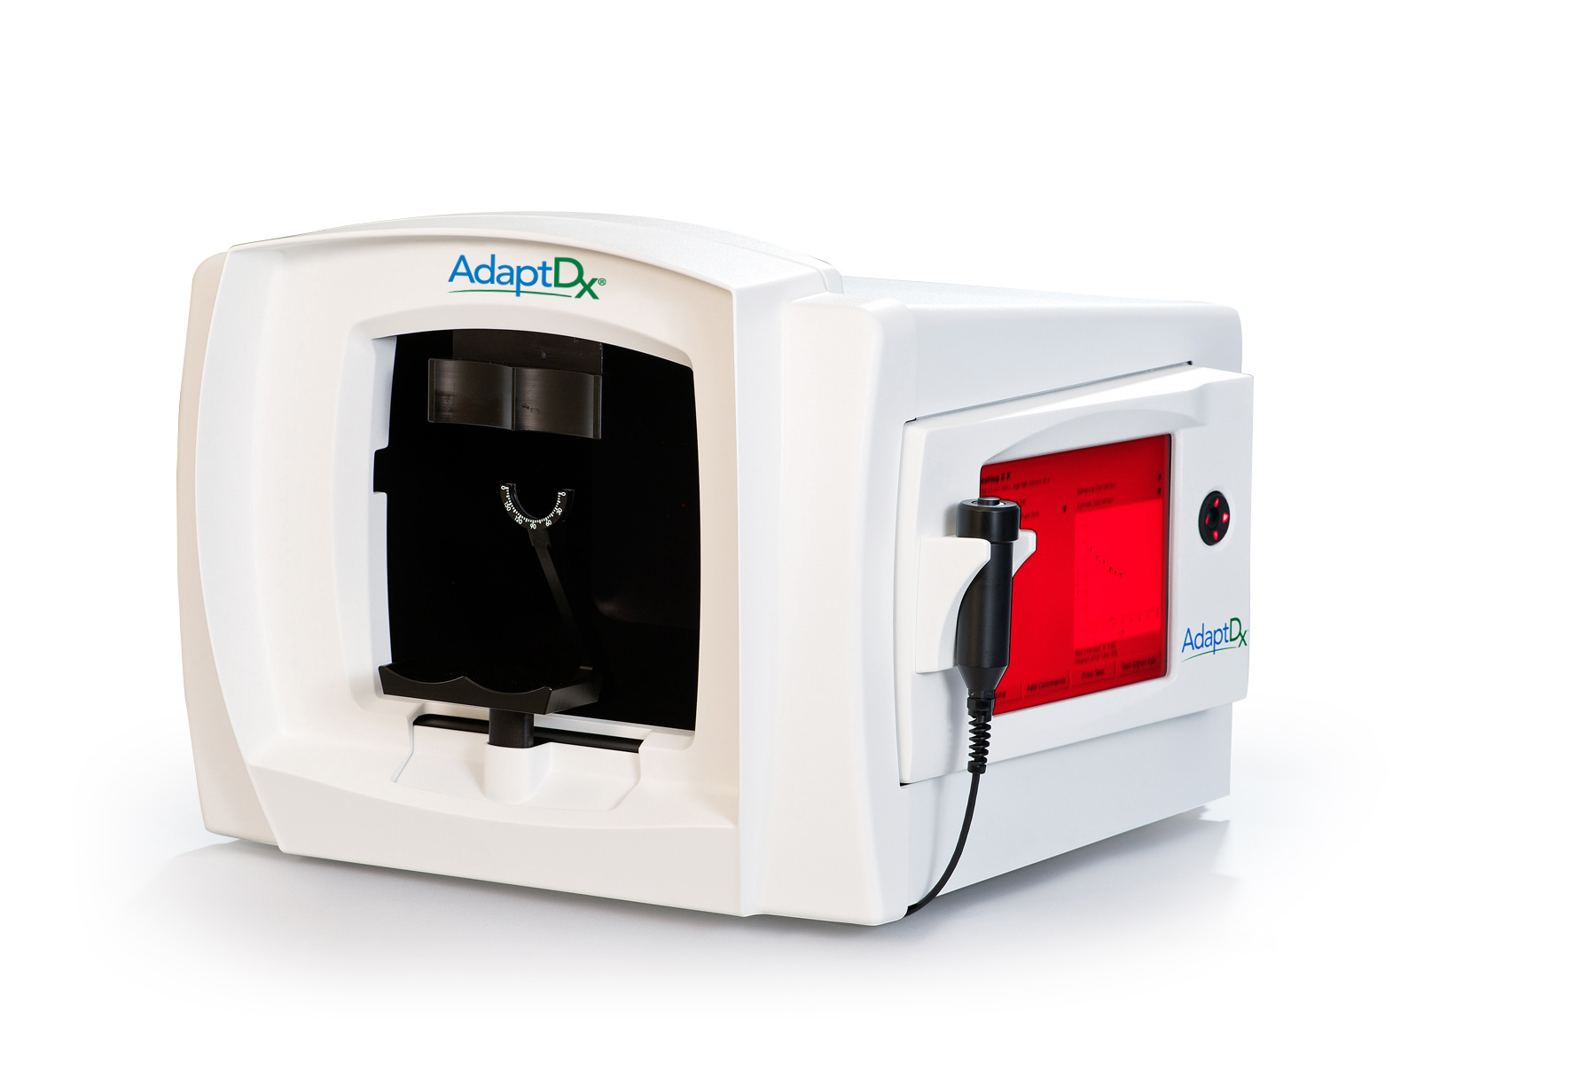

Image of AdaptDx with Technician and Patient

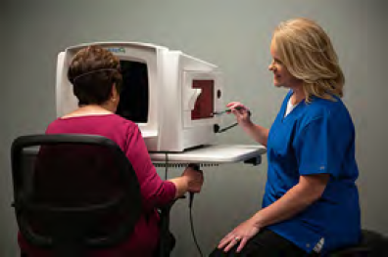
MARKETING AND ADVERTISING COPY
You want to create content on your website, but can’t find the words? We make it easy for you. Cut-and-paste the copy that best fits with the information you currently provide on your website for other diseases and devices.

AdaptDx® Dark Adaptometer
The AdaptDx aids in the detection and management of age-related macular degeneration (AMD). It measures the time it takes for your vision to adjust to the dark. This is called dark adaptation. The simple test takes less than 10 minutes. You’ll look into the device in a darkened room and press a button every time you see a flashing light. If the AdaptDx test indicates signs of early AMD, you and your doctor have valuable time to develop a plan to delay disease progression.

Is the AdaptDx® test covered by insurance?
If there is a medical diagnosis related to AMD or you are experiencing trouble seeing or driving at night, we may be able to bill the test to your insurance provider. If not, the AdaptDx test may require a modest out-of-pocket expense.

VIDEO: AMD Warning Signs
URL: https://youtu.be/G2qRw6ineeo
Video Description:
Are you having problems seeing at night This could be the first warning sign of early stages of age-related macular degeneration. Ask your doctor to test your dark adaptation, the time it takes your eyes to adjust from bright light to darkness, using AdaptDx (adapt-dee-ex)

VIDEO: What to Expect During the Test
URL: https://youtu.be/uEVWu7ucohw
Video Description:
Learn about the AdaptDx and what you can expect from the experience.

VIDEO: RI: An Early Warning Sign of AMD
URL: https://youtu.be/_h1aYM_H52U

Video Description:
Learn how a simple test can help determine if you have age-related macular degeneration (AMD), the leading cause of adult blindness. The AdaptDx is the first and only device to help detect AMD three years before you can see it.

Age-Related Macular Degeneration (AMD)
Age-related macular degeneration or AMD is a chronic, progressive disease that attacks the macula, a part of the retina that allows us see objects located straight ahead of us. The macula is responsible for your central vision, which allows you to do things like recognize faces, read, watch TV, and drive.

Stages of Age-Relate Macular Degeneration
As a progressive disease, AMD reveals itself in stages.

- Subclinical AMD is the earliest detectable stage of age-related macular degeneration. It lasts for about five years and often goes unnoticed. The first warning sign comes in the form of trouble seeing at night. Many people blame poor night vision (caused by impaired “dark adaptation”) on the normal aging process and don’t report the symptom to their doctor.

Don’t make that mistake. If you begin having difficulty driving at night, reading in dim light or adjusting to seeing in the dark, tell your eye care professional. Identifying AMD at this point is critical to delaying significant vision loss.

- Early to Intermediate AMD
Before we learned that dark adaptation is the first symptom of AMD, eye care professionals relied on identifying the disease during the early or intermediate stages. At this point, your doctor may see drusen—yellow deposits of fatty protein under your retina—which is an indicator of AMD.

- Advanced AMD:
During late-stage AMD, people start to notice central vision blurriness. The transition from early-stage to late-stage AMD happens rapidly. If left untreated, it can lead to legal blindness in as little as six months. While treatment options can slow the progression of late AMD, nothing can reverse the damage already done.

AMD Symptoms and Risk Factors
The earliest symptom of AMD is impaired dark adaptation, which may cause difficulty seeing or driving at night. As the disease progresses, symptoms may include distortion of straight lines or dark and blurry central vision.

The primary risk factors for AMD include:
- Age 50 or older
- Family history of AMD
- Caucasian (white)
- Smoker or past smoker
- Overweight
- Heart disease, high blood pressure or high cholesterol

Age is the biggest risk factor. In fact, 1 in 8 adults over the age of 60 have age-related macular degeneration (AMD). If you are experiencing a symptom of AMD or have multiple risk factors, ask your doctor to test your eyes with the AdaptDx®.

AMD Facts
- It is projected that the overall prevalence of the AMD will be 196 million in 2020 and 288 million in 2040¹.
- As many as 11 million people in the U.S. have some form of AMD; this number is expected to double by 2050¹.
- Up to 78% of AMD patients have substantial, irreversible vision loss at first treatment, including 37% who are legally blind in at least one eye^{2,3}.
- Currently, there is no cure for AMD but progression of the disease can be slowed or halted with lifestyle modifications, protective eyewear, and nutritional supplements. Timely diagnosis is therefore key.
- Wet AMD (choroidal neovascularization) may be treated with injections, which can slow or halt disease progression and vision loss, but not reverse it.

What happens if AMD is detected?
If the AdaptDx test indicates signs of early AMD, you and your doctor have valuable time to develop a plan to delay further symptoms.

Proactive steps to delay or prevent vision loss:
- Lifestyle changes, such as improved diet and exercise and quitting smoking
- Eye health supplements
- Blue light protection
- UVA and UVB sunglasses

Your doctor will also want to monitor your vision with AdaptDx testing regularly. If needed, you’ll be able to begin additional treatment as soon as late-stage AMD is detected.

- http://www.brightfocus.org/macular/article/age-related-macular-facts-figures
- Cervantes-Castañeda RA, Banin E, Hemo I, Shipgel M, Averbuhk E, Chowers I. Lack of Benefit of early awareness to age-related macular degeneration. Eye (Lond). 2008;22(6):777-781. (PubMed https://www.ncbi.nlm.nih.gov/pubmed/17220824)
- Olsen TW, Feng X, Kasper TJ, Rath PP, Steuer, ER. Fluorescein angiographic lesion type frequency in neovascular age-related macular degeneration. Ophthalmology. 2004;111(2):250–255. doi.org/10.1016/j.ophtha.2003.05.030. Accessed May 23, 2018.

SOCIAL MEDIA POSTS
Social media can be a great way to advertise your practice and promote AMD testing with AdaptDx. Here are a few ideas to get you started.
If you are over 50, call our office about a simple test that can help preserve your vision. #eyehealth #vision #AMD
We are the first to offer a simple in-office test for the earliest signs of age-related macular degeneration #vision #AMD
If night vision is becoming a problem, you should contact us about a new, simple test that could help preserve your eyesight #vision #AMD
How long does it take your vision to adapt from bright light to darkness? We can tell you – and why it matters! #vision #AMD #eyehealth
Did you know the AdaptDx test is the only way to detect the earliest signs of age-related macular degeneration? #eyehealth #vision
A simple test in our office can help us detect age-related macular degeneration – before it causes vision loss #eyehealth
Over 50? Visit us to learn about other risk factors for #AMD and how to detect it before it affects your sight #vision #eyehealth
Find out if you have early-stage #AMD with a simple test in our office. Together, we’ll protect your vision! #eyehealth

SCRIPT FOR ON-HOLD MESSAGES
Busy practices often have to put patients on hold when they call. What better way to fill up this time than tell them about testing with AdaptDx? Be it for themselves or someone they know; the information is invaluable and may help save someone’s vision. As for your practice, you may be getting a few more calls to schedule testing with AdaptDx

Are you having more trouble seeing or driving at night as you age? If so, this could be the first symptom of age-related macular degeneration, or AMD, which is the leading cause of adult blindness in the US. Click or tap here to enter text. now offers a simple test called the AdaptDx that can help us detect AMD at its earliest stages and take steps to preserve your vision. Ask us about scheduling a test for you or a loved one.

